**Understanding Colorectal Cancer: Trends, Insights, and Key Findings**

**Introduction**

Colorectal cancer remains a significant global health concern, impacting millions of individuals each year. As one of the leading causes of cancer-related deaths, understanding the disease’s patterns, risk factors, and treatment outcomes is essential for improving early detection and treatment strategies. This analysis explores colorectal cancer cases using a dataset sourced from Kaggle and analysed using Microsoft Excel, utilizing Pivot Tables and visualization tools to uncover key insights. By examining factors such as incidence rates, survival rates, and the impact of healthcare access, this study aims to provide actionable recommendations for healthcare policymakers, medical professionals, and researchers.

**Problem Statement**

Colorectal cancer presents a major challenge to healthcare systems worldwide. Despite advances in screening and treatment, many cases are still detected at later stages, reducing survival rates and increasing the economic burden on patients and medical institutions.

The primary issues this analysis seeks to address include:

* Identifying trends in colorectal cancer incidence and mortality rates.
* Analyzing the impact of early versus late-stage diagnosis on survival.
* Evaluating demographic trends, including gender and geographic distribution.
* Understanding the effectiveness of different treatment methods.
* Examining the relationship between healthcare access and survival outcomes.

By uncovering these insights, i aim to support data-driven decision-making to enhance cancer prevention, screening, and treatment efforts.

**Objectives**

This study aims to provide a comprehensive understanding of colorectal cancer cases by:

1. **Analyzing Incidence and Mortality Rates**: Identifying the burden of colorectal cancer and variations in survival outcomes.
2. **Examining Early vs. Late Diagnosis**: Understanding how detection timing influences treatment success.
3. **Assessing Demographic Trends**: Exploring the impact of gender, age, and geographical location on colorectal cancer cases.
4. **Comparing Treatment Outcomes**: Evaluating the effectiveness of different treatment methods, such as surgery, chemotherapy, and radiotherapy.
5. **Investigating Healthcare Access**: Determining how medical resources impact survival rates and disease progression.

**Data Overview**

**Dataset**

The dataset used in this analysis was gotten from Kaggle and includes records of colorectal cancer cases across various countries, covering multiple variables related to patient demographics, diagnosis, treatment, and outcomes.

**Key Variables**

**Independent Variables (Predictors)**

Demographics: Country, Age, Gender

Medical History: Family history, Diabetes, Inflammatory bowel disease, Genetic mutations

Lifestyle: Smoking, Alcohol, Obesity, Diet, Physical activity

Cancer Details: Stage, Tumor size, Early detection

Economic & Healthcare: Costs, Access, Insurance status

Geographic & Socioeconomic: Urban/rural classification, Economic classification

**Dependent Variables (Outcomes)**

Cancer Metrics: Incidence rate, Mortality rate

Treatment & Outcomes: Treatment type, 5-year survival, Mortality status

**Data Cleaning**

Before analysis, the dataset underwent extensive cleaning to ensure accuracy and reliability. The key steps included:

1. **Removing Duplicates**: Ensuring that each patient record was unique.
2. **Handling Missing Values**: Addressing gaps in key fields like treatment type, survival rates, and cancer stage.
3. **Standardizing Data Formats**: Ensuring consistency in numerical values, dates, and categorical data.

**Data Analysis**

**Key Performance Indicators (KPIs)**

Several KPIs were derived from the dataset to assess the burden and outcomes of colorectal cancer:

**Global Disease Burden**: 167,497 Cases. This number shows the total colorectal cancer cases documented worldwide in the dataset. A high case count underscores the significant global impact of this disease and highlights the urgent need for widespread preventive measures and better access to treatment.

**Incidence Rate**: 35 Cases per 100,000 Individuals. The incidence rate tells us how often new colorectal cancer cases occur in a specific population. A rate of 35 per 100,000 indicates that this disease is relatively common, which calls for focused awareness campaigns, screening programs, and lifestyle changes.

**Mortality Rate**: 17 per 100,000 Individuals. This figure reveals how many deaths are attributed to colorectal cancer for every 100,000 people. A mortality rate of 17 suggests that nearly half of those diagnosed (when compared to the incidence rate) do not survive, highlighting the critical need for early detection and effective treatment options.

**Early Detection Rate**: 59.9% of cases were detected Early. Detecting colorectal cancer early can significantly boost survival rates, as it is much more treatable in its initial stages. An early detection rate of 59.9% indicates that screening programs are doing a decent job, but there is need for improvement to identify more cases before they advance.

**Average Healthcare Cost**: $72,452, this number represents the average cost for treating colorectal cancer per patient, which includes surgery, chemotherapy, radiation, and follow-up care. The high costs emphasize the financial strain on patients and healthcare systems, reinforcing the need for more affordable prevention and treatment strategies.

**Average Age at Diagnosis**: 69 Years. The average age at which individuals are diagnosed shows that colorectal cancer mainly affects older adults. This insight is important for channelling screening efforts toward those at higher risk, ensuring that people over 50 are getting the necessary check-ups.

**Analyzing Incidence and Mortality Rates**:

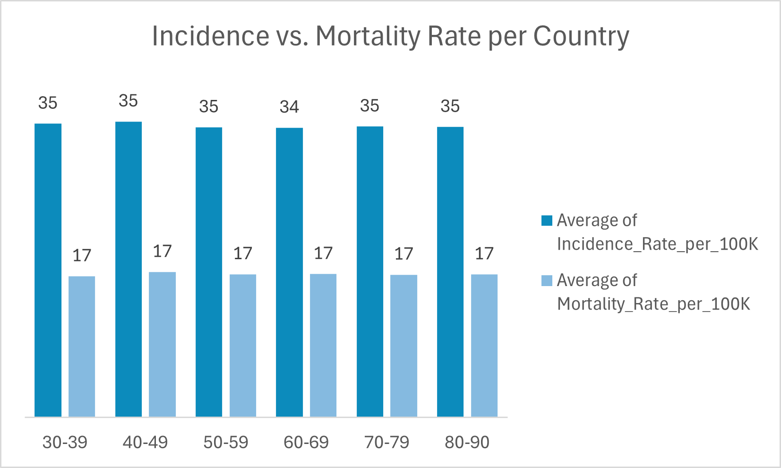

The incidence rate (34.5–35.2 per 100K) remains stable across age groups. The mortality rate (16.8–17.3 per 100K) is significantly lower, suggesting that early detection and treatment improve survival. However, patients aged 70-79 show slightly higher mortality rates, likely due to late-stage diagnoses, weaker immunity, or other medical conditions.

**Examining Early vs. Late Diagnosis**

Only 59.9% of cases are detected early, while 40.1% are diagnosed at late stages. Late-stage diagnoses lead to lower survival rates and higher treatment costs due to aggressive treatments like chemotherapy and radiotherapy. Improving early detection through enhanced screening programs and awareness campaigns is very important.

**Assessing Demographic Trends**

Country-Level Differences: The USA reports the highest colorectal cancer cases (25,927), followed by China (17,525), South Korea (14,107), and Japan (13,924).  
European countries, including the UK, Germany, and France, have moderate case counts, while Canada and Brazil report the lowest.

**Comparing Treatment Outcomes**

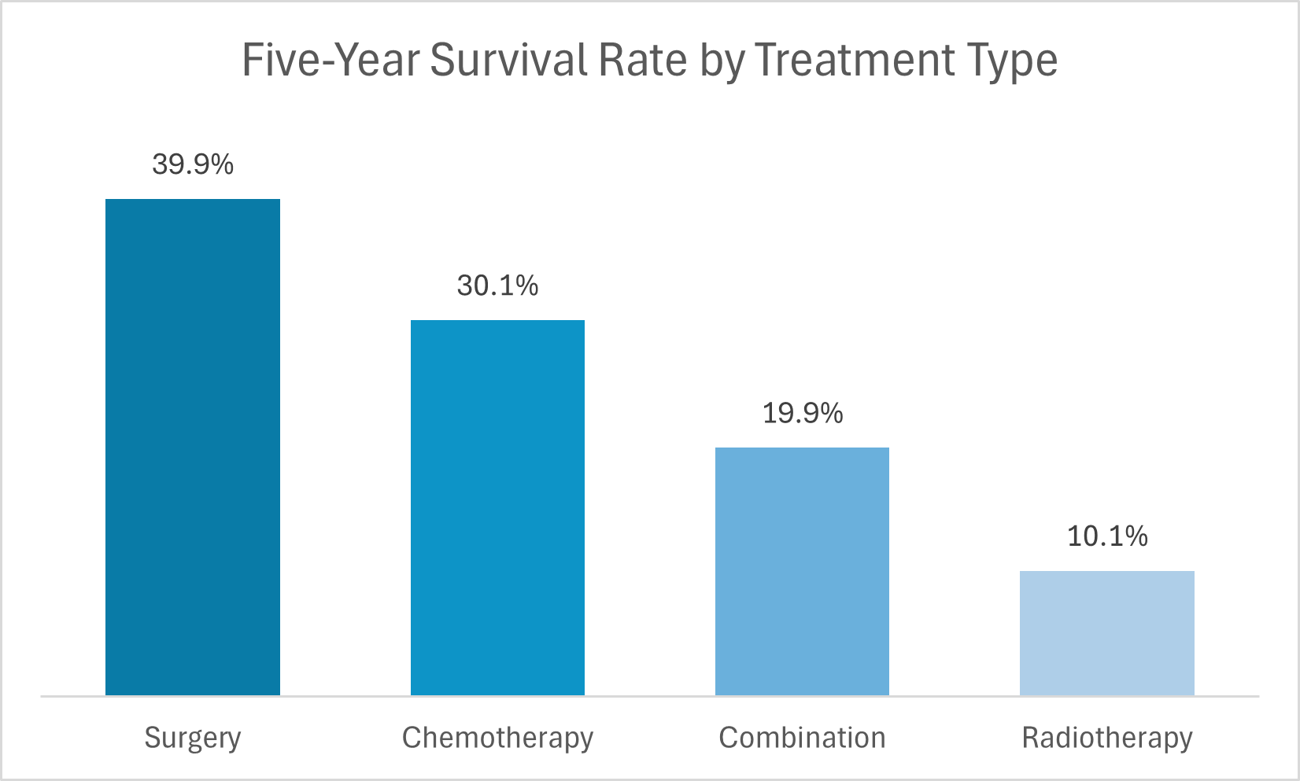

Five-Year Survival by Treatment Type: Surgery (39.9%) has the highest survival rate, making early intervention important. Chemotherapy (30.1%) is typically used for advanced cases. Combination therapy (19.9%) and radiotherapy (10.1%) show lower survival rates, likely because they are used in late-stage or aggressive cancers.

**Investigating Healthcare Access**

Healthcare Access & Survival: Moderate access: 49.9% survival rate, High access: 29.9% survival rate, Low access: 20.2% survival rate, showing limited access leads to worse outcomes.

Healthcare Costs by Age Group: Costs are relatively consistent across age groups ($72,346–$72,595 per patient). This indicates that cancer stage and treatment type impact costs more than age itself.

**Insights**

The analysis revealed several key insights:

* Early Detection is important: A significant difference in survival rates was observed between early and late-stage diagnoses, emphasizing the need for widespread screening programs.
* Higher Mortality in Low-Access Areas: Regions with limited healthcare access show lower survival rates, highlighting the importance of medical infrastructure and resources.
* Gender Disparity in Cases: Male patients (60.1%) were more frequently diagnosed than female patients (39.9%), suggesting potential lifestyle or genetic risk factors.
* Geographic Trends in Cases: Countries like the USA, China, and South Korea reported the highest number of cases, necessitating targeted intervention strategies.
* Surgery as the Most Effective Treatment: Patients undergoing surgery had the highest survival rates, whereas standalone radiotherapy showed limited success.
* Healthcare Costs and Age Trends: The average cost per patient was $72,452, with no significant variation across age groups.

**Recommendations**

Based on these findings, the following recommendations can help improve colorectal cancer outcomes:

1. **Expand Screening Programs**: Increasing early detection efforts can significantly improve survival rates.
2. **Strengthen Healthcare Infrastructure**: Addressing disparities in medical access can enhance treatment success.
3. **Targeted Awareness Campaigns**: Educating high-risk demographics, particularly men, about colorectal cancer risks and screening.
4. **Invest in Surgical Treatments**: Given its higher success rate, policies should prioritize access to surgical interventions.
5. **Optimize Healthcare Costs**: Strategies to manage treatment expenses should be developed, ensuring affordability without compromising quality.

**Conclusion**

Colorectal cancer remains a public health issue, but through strategic interventions such as early detection, and improved healthcare access, survival rates can be significantly improved. This analysis underscores the importance of data-driven decisions in shaping effective healthcare policies and treatment approaches.

By leveraging insights from this dataset, stakeholders can work toward reducing the burden of colorectal cancer, improving patient outcomes, and enhancing healthcare efficiency worldwide.